AIM: Setup DirectX 11, Window Framework and Initialize Direct3D Device

INSTALL YOUR UNITY SOFTWARE AFTER INSTALLATION IS SUCCESSFULLY COMPLETED YOU NEED TO SIGNUP (INTERNET REQUIRED)

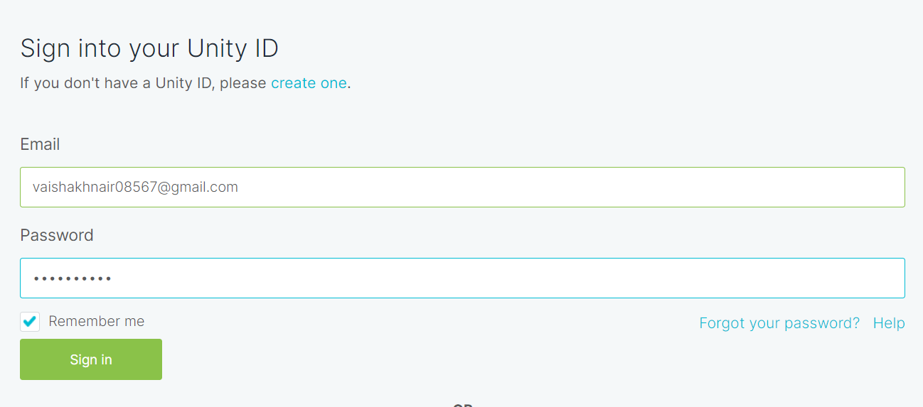AFTER LOGIN IN SELECT THE PERSONAL EDITION FOR YOUR INSTALLATION

CLICK ON NEXT BUTTON AND CHOOSE THIRD OPTION FROM THE CHOICES

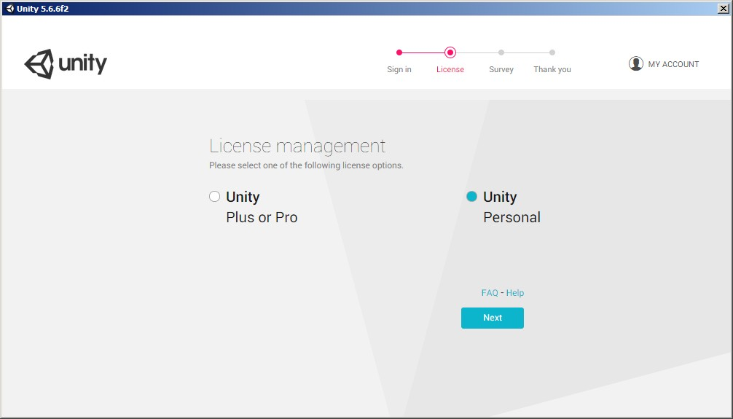

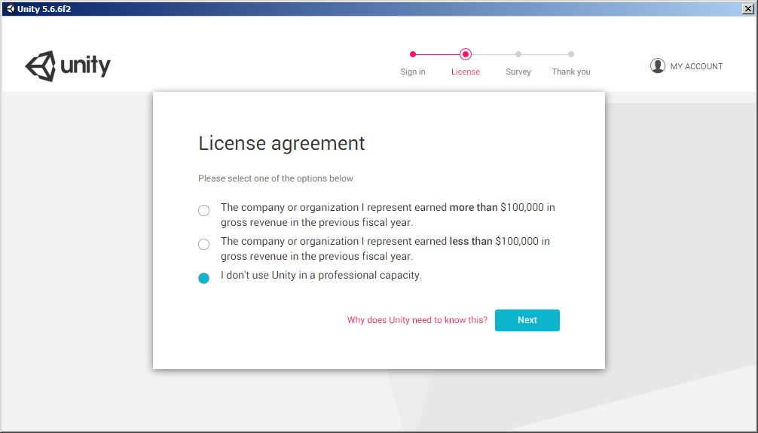

CLICK ON NEXT BUTTON AND U R DONE WITH INSTALLATION PROCESS

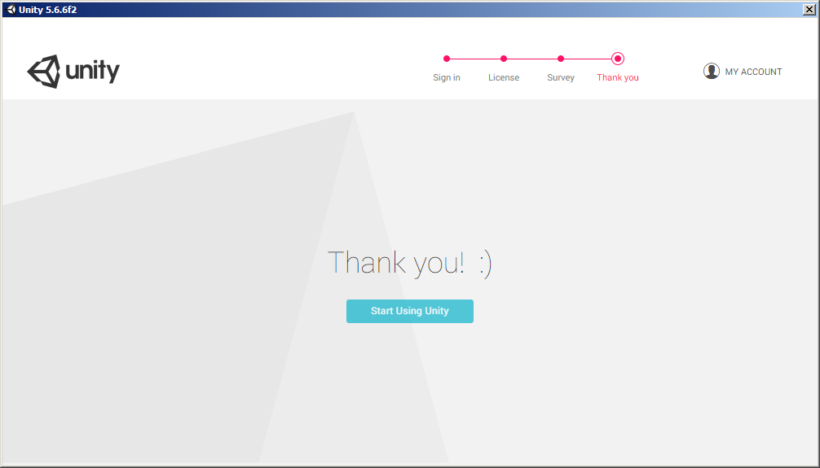

ONCE YOU SUCCESSFULLY LOGIN INTO THE SOFTWARE U CAN WORK IN OFLINE MODE TOO JST SELECT WORK IN OFFLINE MODE

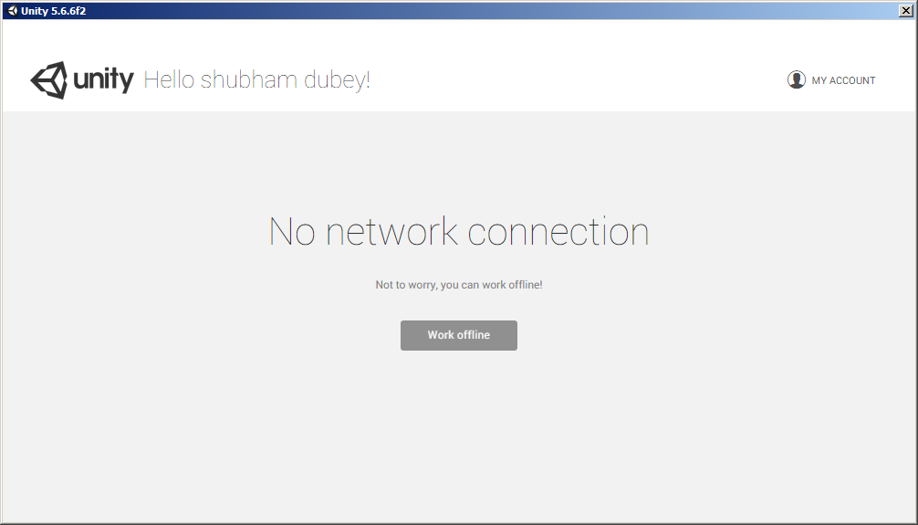

SELECT ON NEW ON UPPER SLIGHTLY LEFT SIDE AND ENTER PROJECT NAME ACCORDINGLY…

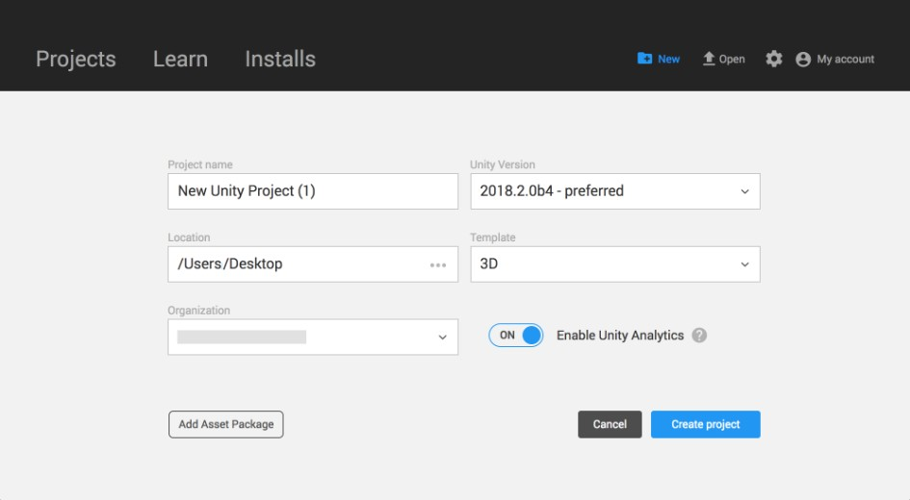

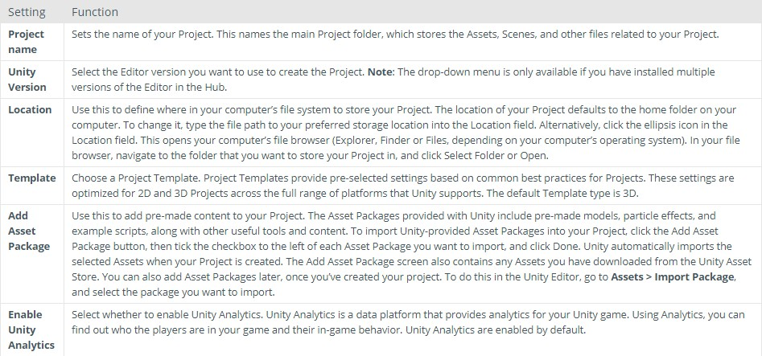

# The Projects tab

On the Home Screen, click **Projects** to view the contents of the **Projects** tab.

CLICK ON EDIT BUTTON AND CHOOSE PROJECT SETTING OPTION ON BOTTON OF BAR AND CLICK ON PLAYER AND A NEW BAR’LL

APPEAR ON RI8 SIDE OF THE SCREEN

# Creating a Project

In the top right corner of the Home Window, click **New** to open the Create Project View.

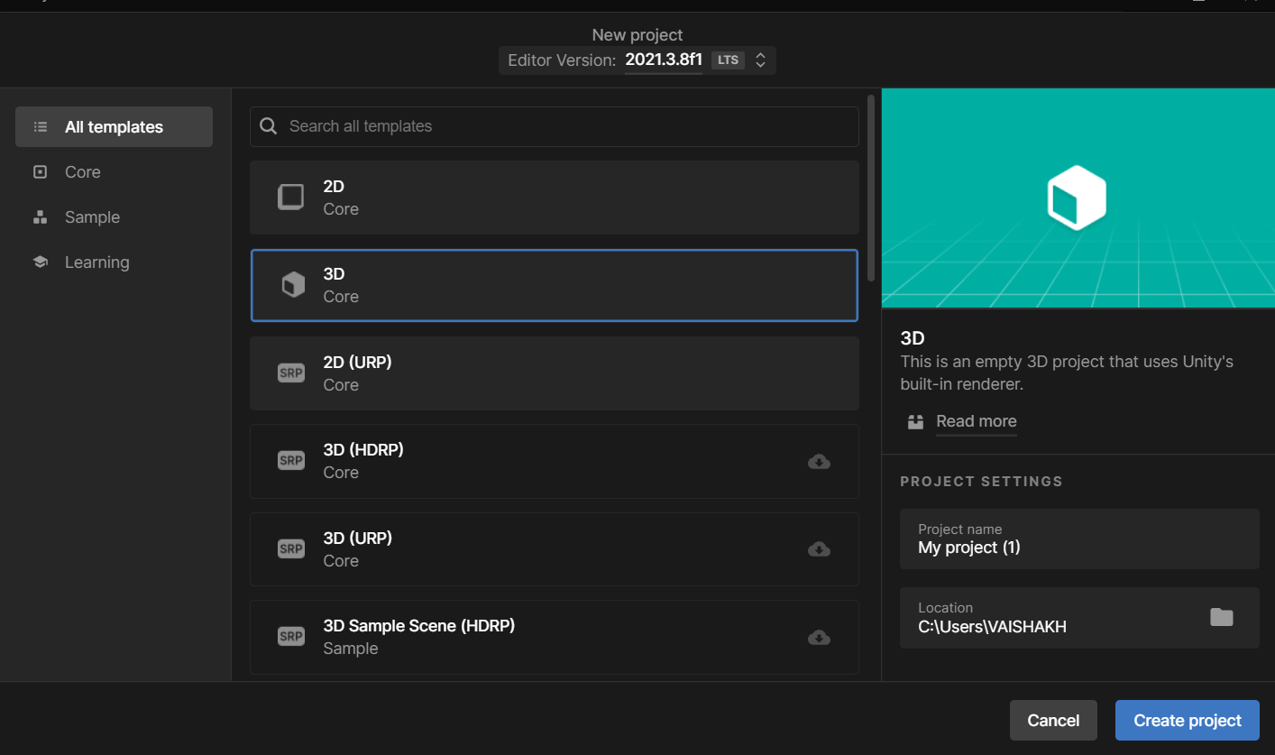

From the Create Project View, there are Project settings to complete before Unity creates your project. These are described in detail below.

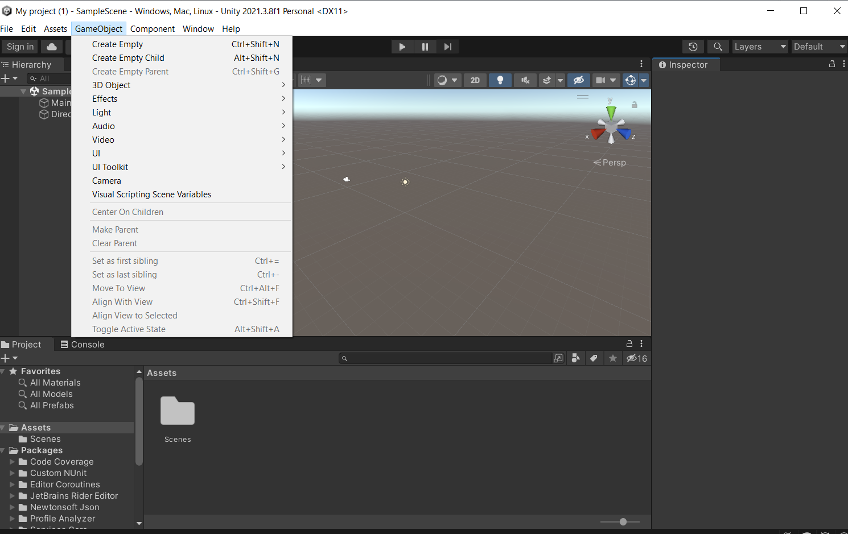

CLICK ON OTHER SETTING AND UNCHECK THE API FOR WINDOWS AND SELECT APPROPIATE DIRECT3D VERSION.

